TC-PM-002
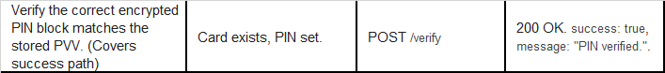
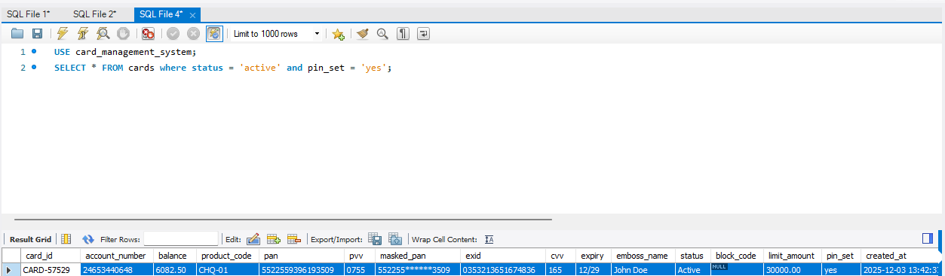
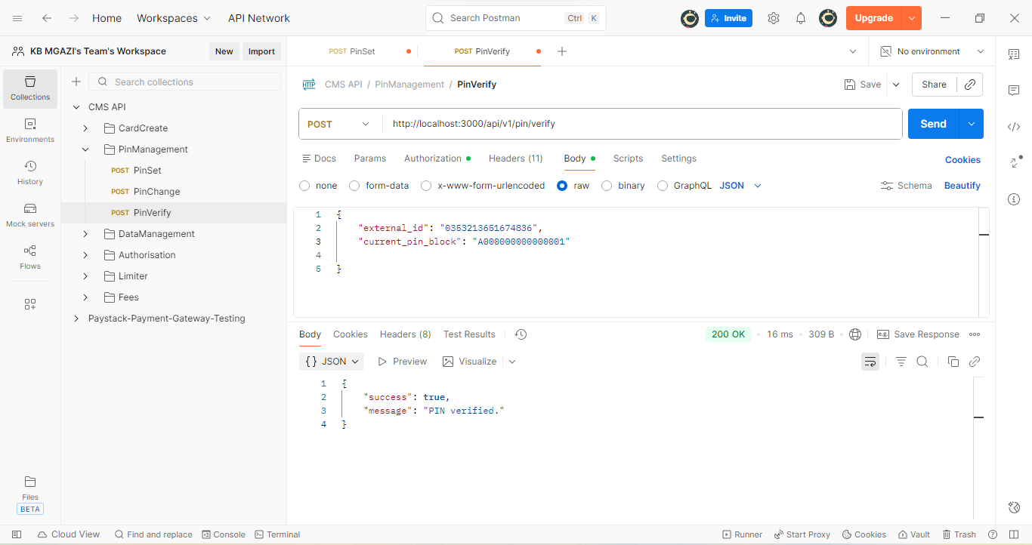
Request:
{
"external_id": "0353213651674836",
"current_pin_block": "A000000000000001"

}
Response:
{
"success": true,
"message": "PIN verified."
}

